

County Wildlife Site

Management plan

Snettisham Common
County Wildlife Site 476

Norfolk Wildlife Trust
Updated 2020

Contents

- Background

- History

- Habitats & current site condition

- Vision

- Aim of management plan

- Conservation priorities & aims of management work

- Indicators of success

- Constraints

- Management prescriptions

Appendix 1 – Geological management Plan

Appendix 2 – Citation

- Background

This County Wildlife Site includes the registered common land itself, used in the past for local sand extraction, plus a triangle of adjacent woodland and another triangle of acid grassland alongside the disused railway. The Common is comprised of steep scrub woodland slopes with an area of ericaceous heath and more established woodland further north. A large sand pit in the west has sheer cliffs and is of geological interest. The main area of land is open to the public with several paths around the site and is well-used by dog-walkers.

Snettisham Common was notified as a county wildlife site in 1984. The site was re- surveyed in 2012. This site was selected because it met the criteria for County Wildlife Status based on its woodland, heathland and grassland features.

The site also contains a pit of geological interest. For specific management prescription relating to this feature please see Tim Holt-Wilson’s plan attached as Appendix 1.

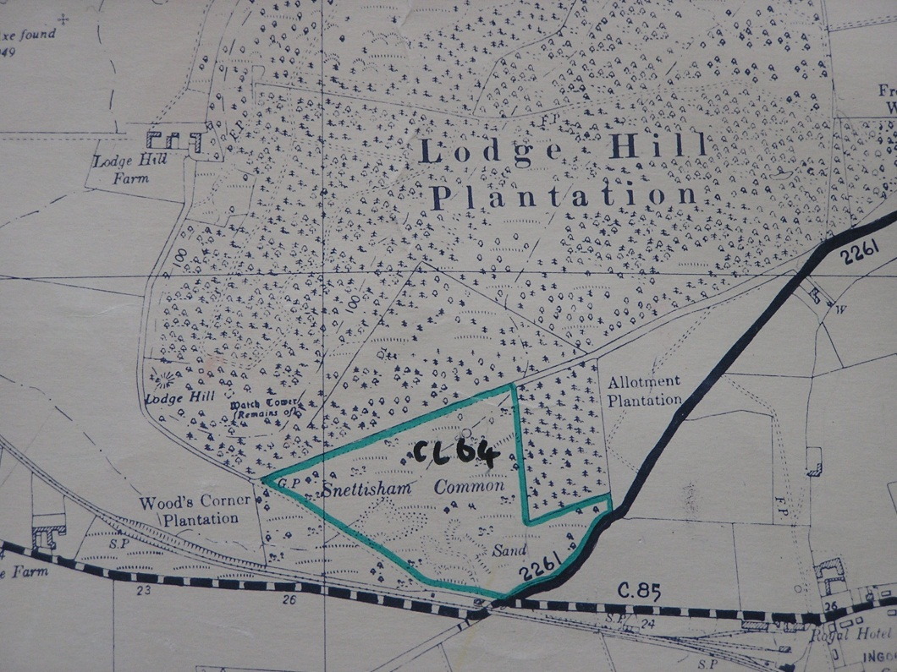
Figure 1: Map showing the Snettisham Common County Wildlife Site Boundary

This management plan follows on a previous version written in 2019; since then, Snettisham Parish Council and their volunteer group have worked to restore and manage the site. This has included a project to open up the sandpit to public views and to protect the cliff face itself by removing vegetation from the base.

Volunteers have also worked towards removing scrub from the heathland areas and re-connecting the two fragments of heath.

Work to the heath and to the sand pit has also helped people understand the wildlife of the Common and allowed people to be actively involved in its care.

The efforts of the volunteers was recognised in 2019, when they received a Norfolk Community Biodiversity Award. This award “recognises the achievements of groups working on biodiversity projects in their local community. Local groups can inspire people to recognise and care for their local biodiversity while providing the chance to get together and work with a common purpose. We are looking for results for participants and the group as a whole, as well as those achieved for wildlife and habitats.”

The “highly commended” award was for work to improve Snettisham Common for wildlife.

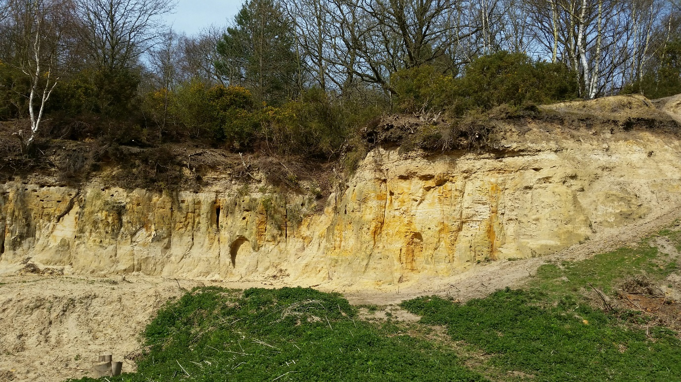
Figure 2: Restored sand pit 2019

- History

Snettisham Common has a long history of use as common land. The Common is shown on Fayden Map of Norfolk, in 1797. Snettisham Common was registered as common land (CL 64)

The main part of the site is owned by Snettisham Parish Council. In addition to this a small portion of the land is owned by Ken Hill Estates. The land owned by Ken Hill is not part of this management plan.

Following the Second World War the site was used to dump materials. This W.W.2 dump can be found to the north the of site.

A first known management plan for this site was written in 1992, and has similar objectives to the current plan, with work including scrub clearance and other minor work.

A subsequent management plan was written in 2014; following this plan, significant work was carried out on the site. The sand pit was opened up so it can be easily viewed, a short path created to it and management of the heathland re-instated. This involved removing pine and birch trees and seedlings, cutting and raking areas of heath and starting the work of re-connecting the two areas of heath.

The establishment of a conservation volunteer group within in the village has made great strides in the management of the site and also in helping residents and visitors to the Common understand more about the wildlife that is there and the management that is needed.

The 2014 management plan set out a 5 year vision; the following table assesses progress against this:

Table 1 – progress against 2014 Management Plan
Vision | Progress
The two areas of relict heath will cease to be threatened by encroachment of birch scrub and will become more open, less heavily shaded and dominated by heather and heathland grasses, with a mix of ages of individual heather plants. | Partly achieved.  This has been tackled slowly to be within the capacity of the volunteer group and to soften the impacts of visitors.  Some areas of birch still to be removed.
Areas of secondary woodland will remain largely unchanged, but some woodland management will be achieved potentially as a result of a “wood for work” scheme.  Conservation Volunteers or contractors will allow creation of a more diverse age structure by coppicing scattered trees. | Partly achieved, again within capacity of volunteers.
The area directly beneath the sand pit area will remain unchanged in accordance with geological advice, but the face will continue to be kept open. | Achieved & on-going maintenance required.  Scree at base of cliff cleared to protect cliff and allow access/visibility.
Visitor experience of the site will be improved by the provision of an interpretation board in the car parking area.

- Habitats and Current Site Condition

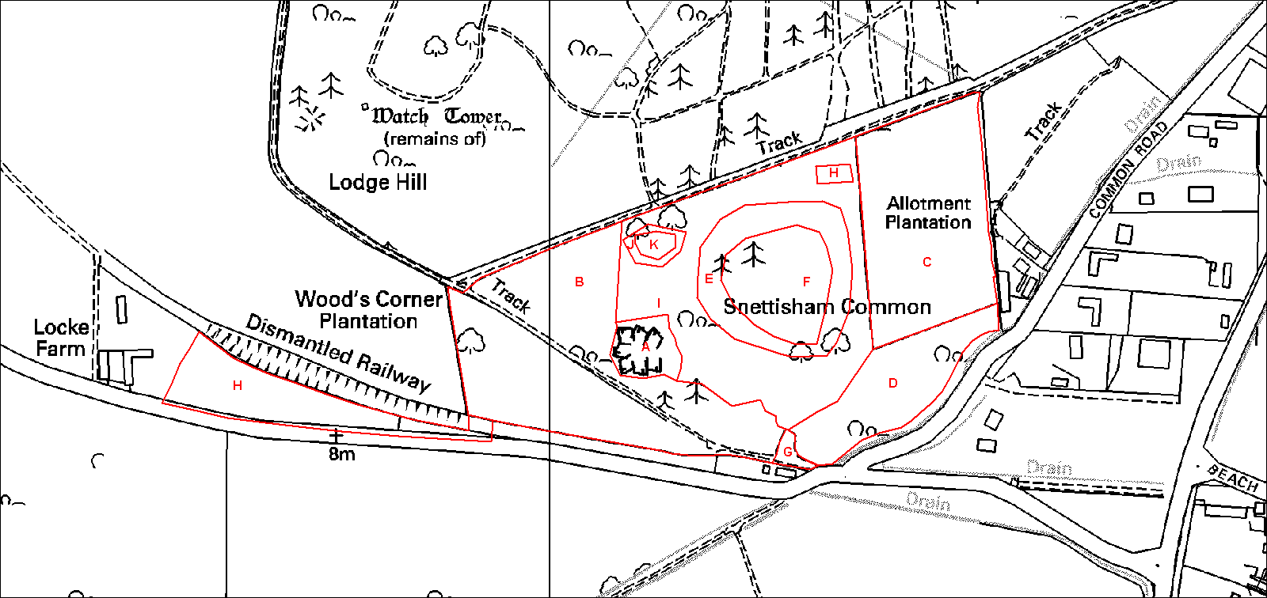

Area | Habitat Type
A | Quarry
B | Woodland
C | Allotment plantation
D | Semi-natural Woodland
E | Transition area of heath and woodland
F & K | Dry Acid Heath
G | Car Park
H | Old Dump
I | Semi Natural Woodland
J | Transition area of heath and Woodland

Figure 3: Habitat compartments at Snettisham Common

- Car Park: The area adjacent to the car parking area does not have any interpretation about the site for visitors.

- Secondary Woodland: The woodland is mainly comprised of English oak Quercus robur and Silver birch Betula pendula, with some Sycamore Acer pseudoplatanus. The age structure is generally even aged with most of the trees being mature. A scrub layer exists in some places comprising of Hawthorn Crataegus monogyna, Bramble Rubus fruiticous agg. and Gorse Ulex europaeus. The scrub and secondary woodland are mostly unmanaged. The understory is comprised of locally abundant Broad buckler fern Dryopterisis dilatata and occasional Wood sage Teucrium scorodonia. There is little fallen deadwood in the woodland.

- Heathland: Ling heather Calluna vulgaris dominates the heathland with most stands being over mature. Encroachment by Silver birch saplings is occurring into the heathland trees from around the edges.

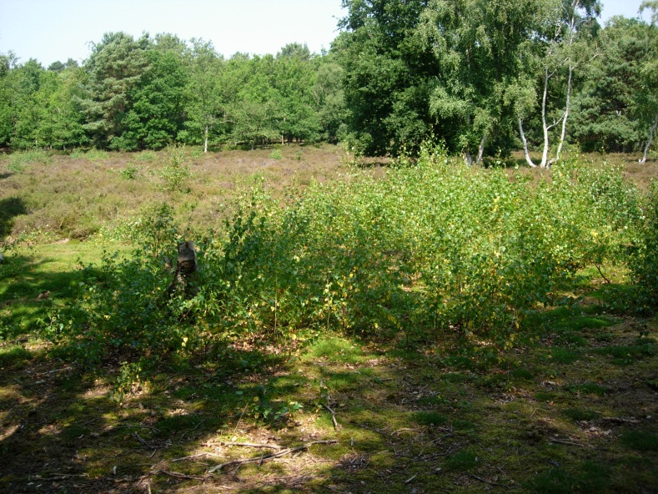

Some heather regeneration is visible in areas of bare ground. In the north western corner there is a small amount of Bell heather Erica cinerea.

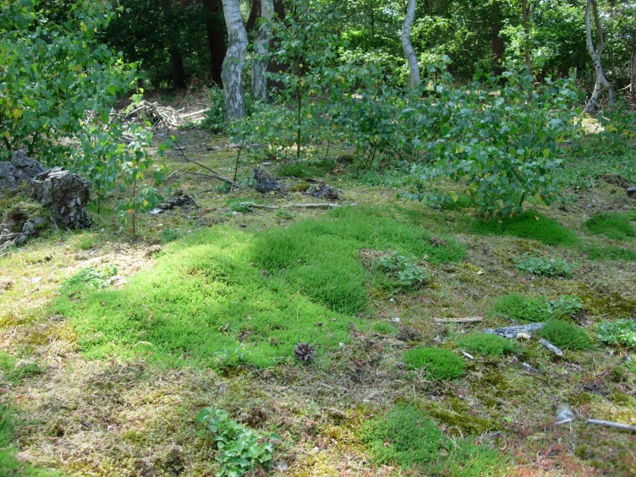

- Sand Pit: Exposed geological features are being maintained by the removal of scrub encroachment onto the quarry face. The faces are deeply-fissured and fractured in places, and contain many holes once used by Sand martin Riparia riparia and small holes excavated by solitary bees and wasps. Abundant Common nettle Urtica dioica grow at the base of the quarry, and are currently unmanaged.

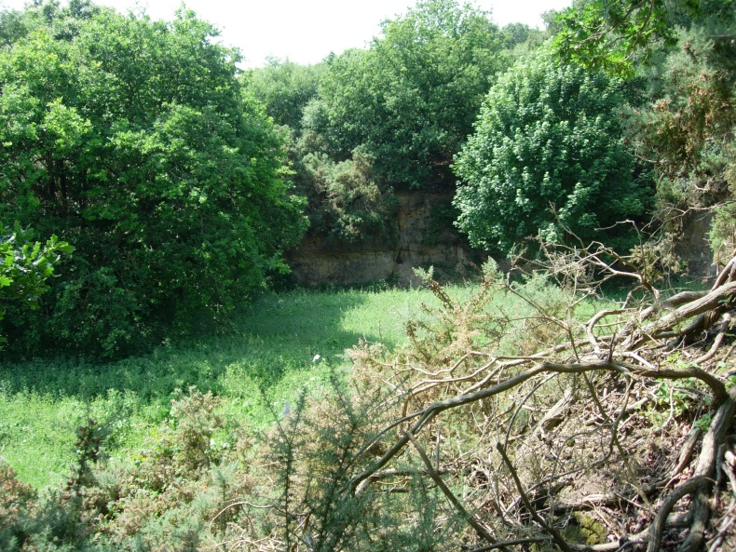

- Rubbish Dump: This area comprises material dumped after WW2. Whilst being interesting from a social history point of view, in the past, concerns have been expressed about allowing access to this area, as there is no record of the dumped material.

The principal threat to this site is currently the encroachment of trees into heathland areas and the consequent lack of recruitment of new ericaceous plants.

- Vision for 2020-2025

In the next five years the two areas of relict heath will cease to be threatened by encroachment of birch scrub and will become more open, less heavily shaded and dominated by heather and heathland grasses.

A mix of ages of individual heather plants will be achieved through implementing cutting and raking of heather areas on rotation.

Trees and scrub between the two areas of heath will be slowly removed to allow the two areas to be connected.

The areas of secondary woodland will remain largely unchanged, but some woodland management will be achieved potentially as a result of a “wood for work” scheme. Conservation Volunteers or contractors will allow the creation of a more diverse age structure by coppicing scattered trees.

The area directly beneath the sand pit area will remain unchanged in accordance with geological advice, but the face will continue to be kept open and the open area in front of it cut regularly.

The visitor experience of the site will be improved by the provision of an interpretation board.

- Aim of Management Plan

The aim of this management plan is to set out an action plan for restoring parts of the site to lowland heath/acid grassland. Lowland heath and acid grassland are priority habitats for biodiversity work in Norfolk, and targets for maintaining and expanding the county’s heathland resource are set out in the Norfolk Lowland Heath and dry acid grassland Habitat Action Plan, which can be found at: http://www.norfolkbiodiversity.org/actionplans/habitatactionplans/lowland_heathland.aspx

- Conservation priorities 2020-2025

- Improve environmental understanding through the provision of an interpretation board to inform visitors about the geological importance and natural history of the site.

- To improve the wildlife value of the woodland through increasing the range and diversity of age classes in the secondary woodland through coppicing and increasing the amount of dead wood - this is of particular value to invertebrates.

- To manage existing areas of heathland to increase the diversity of age-classes in the heather and remove the threat posed by encroachment by birch saplings though removal of saplings and mature trees in adjoining areas which act as a seed source.

- To increase the area of existing heathland and increase connectivity between existing heathland fragments.

- To maintain the existing geological value of the sandpit feature

- Maintain access through bridleways and rides through regular scrub removal

- Create new areas of acid grassland along edges of track ways

- Eradicate Rhododendrons Rhododendron sp. from the site

A detailed breakdown of management tasks can be found in Section 9: Management prescriptions

- Indicators of success

- By year 5, increase in the total area of heathland
- By year 5, increase in the diversity of the age-structure in the heather
- By year 5, increase in the age structure of the secondary woodland
- By year 5, Rhododendron will have been eradicated from the site

- Constraints

- Public access
This is an open access site heavily used by dog walkers; there is therefore a need to maintain public access. If any areas need to be closed for work, hazard signs and appropriate precautions need to be taken to ensure public safety.

- Fire
No fires should be allowed on the site as the dry nature of the habitat renders it vulnerable to fire damage. If fires are required for purposes, they should be used sparingly and only with approval from the Parish Council.

- Fencing and common Land
Common land cannot legally be enclosed without permission from the Sectary of State. This permission is expensive to obtain and does not convey sufficient benefits to the site at this time. Options for short term grazing may be appropriate in the future and these could be advised by NWT staff.

- Felling licence
Felling licences are required for some tree felling work.
A licence is not required under the following circumstances:
- to fell less than 5 cubic metres in a calendar quarter (Please note that you cannot sell more than 2 cubic metres in a calendar quarter)
- for trees that have the following diameters when measured 1.3 metres from the ground
  - 8 cm or less
  - 10 cm or less for thinnings
  - 15 cm or less for cutting coppice
The Timber Volume Calculator can help work out the volume of timber in question and is available at: http://www.forestry.gov.uk/pdf/TimberVolumeCalculator.pdf/$FILE/TimberVolumeCalculator.pdf

- Archaeology
There are no archaeological constraints at this site. Checked on www.hertitage .norfolk.gov.uk. Accessed online 08/10/2013.

- Management prescriptions
Conservation priorities | Prescriptions | Year/s | Timing | Who to deliver | Details
Car Park  Increase environmental understanding | Providing interpretation boards | 1-3 years | Any | Parish Council | Seek funding
Secondary Woodland  Open up and widen rides  Increase standing and dead wood  Thinning of Sycamores in the North West corner of the woodland | Introduce coppicing to the accessible areas. Coppicing is the cutting back of trees and allowing them to re-grow  Areas of standing and fallen dead wood should be left to provide an important habitat for wildlife in the woodland  Introduce coppicing to the accessible areas | 1- 5 years  1-5 years  1-5 years | October to February  October to February  October to February | Volunteers  Parish council to control felling work.  Parish Council and volunteers  Volunteers  Parish council to develop felling contacts and management | This could be achieved through a wood for work scheme which would allow some trees to be coppiced for firewood  This could be achieved through a wood for work scheme which would allow some trees to be coppiced for firewood  Develop controls to limit felling possibly by the issuing of felling contracts or the marking of trees by the Parish Council
Lowland Heathland  Manage area of open heath sustainably & increase age structure & structural diversity  Control Birch and oak sapling encroachment  Remove mature birches within the heathland  Remove mature birches from around the heathland  Mature oak in heathland  Reconnect heathland fragments  Remove tree saplings from fragmented heathland  Remove mature birch trees from around fragmented heathland  Consider the removal of either the pine or the oak/ or reduction in their size through the removal of limbs  Control bracken | Cut new patches within the heather that represent less than 10% of the total area each year.  Birch and oak saplings should be removed from the heathland  Mature birch should be removed from with the heathland  Remove birch trees from around heathland  The oak in the centre of the heathland could be removed  Remove mature trees and any other trees that are causing significant shade  Remove tree saplings  Remove mature birch trees  Bracken levels should be monitored annually and control considered if spreads into heathland | 1-5 years  1-5 years  1-5 years  1-5 years  1-5 years  1-5 years  1-5 years  1-5 years  1-5 years  2-3 times a year | November to January  October to February  October to February  October to February  October to February  October to February  October to February  October to February  October to February  June to August | Parish Council and volunteers or contractor  Parish Council or volunteers | Cut heather in patches, in a random mosaic, Cut <10% every 2 years or so. Cut with brush cutter or pedestrian mower  Cut heather material should be raked up and removed under the trees around the heathland edge.  Create bare ground. Newly created bare ground should be disturbed to facilitate regeneration by heather and provide a key habitat for reptiles with in the heathland  These can be cut by hand, but must be treated with an herbicide e.g. Roundup*, within an hour of felling. This prevents regeneration of multi-stemmed trees  This could be achieved by either cutting or ring-barking followed by treatment with herbicide to prevent regrowth  This would extend the boundary of the heath and reduce the seed source. This could be achieved by ‘ring-barking’ the trees.  This would extend the boundary of the heath and reduce the seed source. This could be achieved by ‘ring-barking’ the trees.  Treat stumps with a herbicide E.g. Roundup* to prevent regeneration  This could be achieved through ring barking or cutting by a contractor  Cut & tree or remove with a ‘tree popper’*  This would extend the boundary of the heath and reduce the seed source. This could be achieved by ‘ring-barking’ the trees.  This would extend the boundary of the heath and reduce the seed source. This could be achieved by ‘ring-barking’ the trees.  These should be cut or treated with Asulox solution or round up. Cut 2-3 times a year or spot treat with an appropriate chemical
Sandpit  Nettles  Maintain access to the South east | No management required at present  Reduce scrub along path edges |  |  |  | Cut back open area annually.  Manage in accordance with Tim Holt-Wilson’s advice provided in Appendix 1
Bridleway  Maintaining access and creating acid grassland if possible  Rhododendron control | Regular scrub removal  Widen the areas alongside the pathways to create areas of acid grassland  Removed from along the bridle way and the adjoining woodland |  |  |  | This could be done by hand.  These should be cut and treated with copper sulphate solution or Round Up
Rubbish Dump  Managing Access | Create dead hedging from brash being removed from other parts of the site
Review management plan | The plan duration is five years, but should be reviewed annually with NWT staff and Snettisham Parish Council | Annually | Autumn | Norfolk Wildlife Trust and Parish Council
Seek further funding |  | Annually | All year | Norfolk Wildlife Trust and Parish Council

Notes
* Use of Round –Up by spraying requires a licence, however stump treatment maybe permitted on parish council owned land, if applied by brush.

An alternative on large stumps is to use ‘eco-plugs’ – these are small capsules containing herbicide, they are used by hammering lightly into a drilled hole in the stump to release the herbicide.

* ‘tree poppers’ are a specialised tool for removing saplings. See https://www.youtube.com/watch?v=oe7U0593vzc for a demonstration.

Appendix 1: Geological Management Plan

SNETTISHAM COMMON PIT

Prospects for geoconservation

The Site

Snettisham Common is a County Wildlife Site (CWS 476), and includes a former sandstone quarry at NGR TF 6710 3362. This quarry exposes strata of the Sandringham Formation of Lower Cretaceous age (Leziate Beds) showing cross-bedding features, overlain by strata of the Dersingham Formation (Dersingham Beds) which include sands, clay and clay ironstone. A notable feature of the site is faulting, which trends in two directions, and may be associated with glacial loading or periglacial cambering. The Leziate Beds are thought to have been extracted here for building stone in the 19th century. Aerial photographs from 1946 suggest that the quarry may also have been active in the 1940s. Judging by its contents, an old gravel pit to the north is thought to have been backfilled with rubbish in the early 20th century.
For geological information, see:
- W Whitaker and A Jukes-Browne: ‘The Geology of the borders of The Wash’ (Memoirs of the Geological Survey of Great Britain; 1899), p.9;
- RW Gallois: ’Geology of the Country around King's Lynn and The Wash’ (Sheet Memoirs 145 and 129 (part), British Geological Survey; 1994), pp77-78.

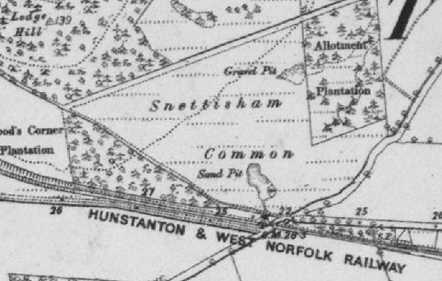
Snettisham Common Pit (1st edition OS map, courtesy Norfolk eMap Explorer)

Condition

The quarry is about 30 m x 20 m in extent, with an access slope on the south-eastern side and vertical exposures reaching up to 5 metres in height on the other three sides. It has notably accessible geological exposures, although its scientific and educational interest is compromised in three main ways:
- Spreads of talus have accumulated at the foot of the exposures, most notably on the north-eastern side; it is not known how deeply they have buried the original foot of the quarry wall.
- Sycamore trees mask exposures on the northern side, and gorse bushes and brambles mask them on the north-eastern side.
- Graffiti has been carved onto many exposed surfaces, masking geological details, but not impairing the stratigraphic, sedimentary and structural interest of the site.

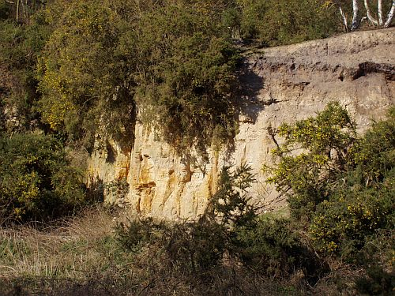
North-eastern exposure, showing gorse and bramble encroachment

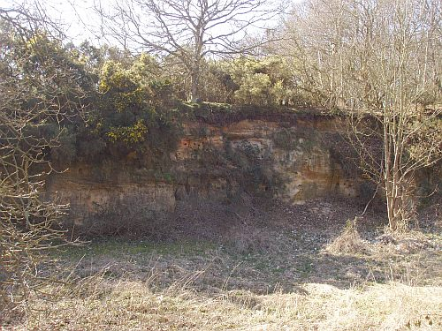
North-western exposure, showing talus spread and sycamore and gorse encroachment
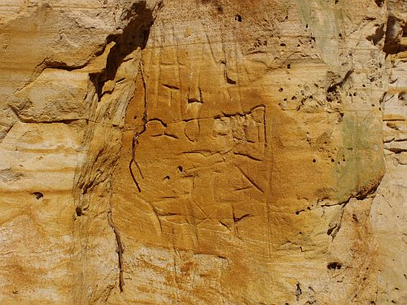
Example of graffiti damage to the north-eastern exposure

Views about management

To conserve the geological interest of the site the following initial recommendations are made:
- It would be desirable to remove as much vegetation from the floor of the quarry as possible, particularly the sycamore trees, brambles and gorse obscuring the northern and north-eastern walls; this will help make the geological features more visible.
- An oak tree shading the north-western quarry walls from above may be retained, as it is helping to shelter the exposures from weathering.
- Graffiti should be discouraged, if at all practicable.
- The build-up of talus at the foot of quarry walls should be removed, to re-expose the foot of the walls and to remove a ready growing medium for gorse, brambles and other vegetation.
Opening up the quarry walls is likely to benefit wildlife, by improving nesting, basking and hunting ground for thermophilous fauna, such as hymenoptera.

Possible CGS status

Snettisham Common Pit would make a good candidate County Geodiversity Site on the following grounds:
- It is a notable exposure of the boundary between the Leziate Beds and Dersingham Beds;
- It has a history of published geological research;
- It has displays good geological structures, notably faulting (rarely visible in Norfolk), and cross-bedding;
- It is a publicly accessible site, with clear educational potential.
- It is the subject of active interest by the Parish Council and local nature conservationists.
For more information about geoconservation priorities in Norfolk see section 3.3 of ‘Norfolk’s Earth Heritage’ (Norfolk Geodiversity Partnership; 2010).
Tim Holt-Wilson
3-9-2012
Appendix 2: Citation

County Wildlife Site Survey Form
(Ref. No. 476)

Site Name: Snettisham Common Parish: Snettisham
Grid reference: TF 673337 Area: 12.79 ha
District: King’s Lynn & West Norfolk Survey dates: 1.3.12, 30.5.12

This site includes the Common itself, used in the past for local sand extraction, a triangle of adjacent woodland and another triangle of acid grassland alongside the disused railway. The Common is comprised of steep scrub woodland slopes with an area of ericaceous heath and more established woodland further north. A large sand pit in the west has sheer cliffs and is of geological interest. The main area of land is open to the public with several paths around the site and is well-used by dog-walkers.

Most of the site is woodland, composed mainly of oak Quercus robur and silver birch Betula pendula, with some sycamore Acer pseudoplatanus and frequent broad buckler fern Dryopteris dilatata. The lower slopes of the site have many hills and holes, and support only stunted oak and hawthorn Crataegus monogyna with abundant bramble Rubus fruticosus agg. and honeysuckle Lonicera periclymenum, which becomes a denser growth of silver birch and oak further north with occasional Scot’s pine Pinus sylvatica and dense thickets of self-set hawthorn and some gorse Ulex europaeus. Further north and west, sweet chestnut Castanea sativa and young beech Fagus sylvatica and rowan Sorbus aucuparia occur, with Scot’s pine Pinus sylvatica north of the heather area. The Allotment Plantation in the east has many Scot’s pine and younger Turkey oak Quercus cerris mixed with the other species, with a negligible ground flora, and has more fallen deadwood. Many mature trees edge the woods, with some particularly fine oak and veteran sweet chestnut. The triangle of land south of the public footpath is an area of dry oak and sycamore woodland, more densely-wooded in the west. The acid ground flora includes sheep’s sorrel Rumex acetosella, sweet vernal-grass Anthoxanthum odoratum, early forget-me-not Myosotis ramosissima, field woodrush Luzula campestris, sand sedge Carex arenaria, male fern Dryopteris filix-mas and spring beauty Claytonia perfoliata, and several large clumps of heath speedwell Veronica officinalis. On the whole, there is little fallen deadwood in these woodlands.

A large area of over-mature heather Calluna vulgaris heath lies approximately in the middle of the site. The birch around the edges of the heather are gradually being cut back, leaving the oak standing, and at the northern edge young heather and bell heather Erica cinerea are regenerating well in the light sandy soils.

The western triangle of acid grassland is rabbit- grazed and gorse has been cut back. Species include abundant sheep’s sorrel, with sweet vernal-grass, field mouse-ear Cerastium arvense, mossy stonecrop Crassula tillea, sticky mouse-ear Cerastium glomeratum, hoary ragwort Senecio erucifolius, mouse-ear hawkweed Pilosella officinalis and field woodrush with sand sedge by the road. The cutting has steep 6m cliffs of partially-cemented sand of different colours, with much soft eroded sand at the base of the cliffs; there are numerous rabbit burrows and evidence of digging throughout.

A small stream, ochrous in parts, runs along the eastern edge of the Common. A few downy birch Betula pubescens and alder Alnus glutinosa grow on the edge of the stream, with some water figwort Scrophularia auriculata and hemp agrimony Eupatorium cannabinum; the vegetation becomes taller and denser further south, with frequent great willowherb Epilobium hirsutum, hop Humulus lupulus and hemlock Conium maculatum.

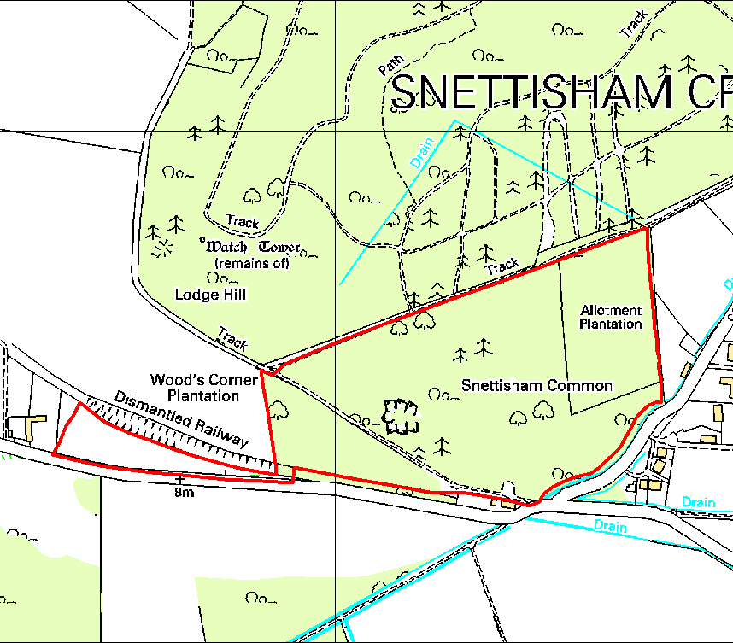
© Crown copyright and database rights 2013 Ordnance Survey 100019340

